Schools must use the funding to make **additional and sustainable** improvements to the quality of PE and sport they offer. This means that you should use the Primary PE and Sport Premium to:

* develop or add to the PE and sport activities that your school already offers
* 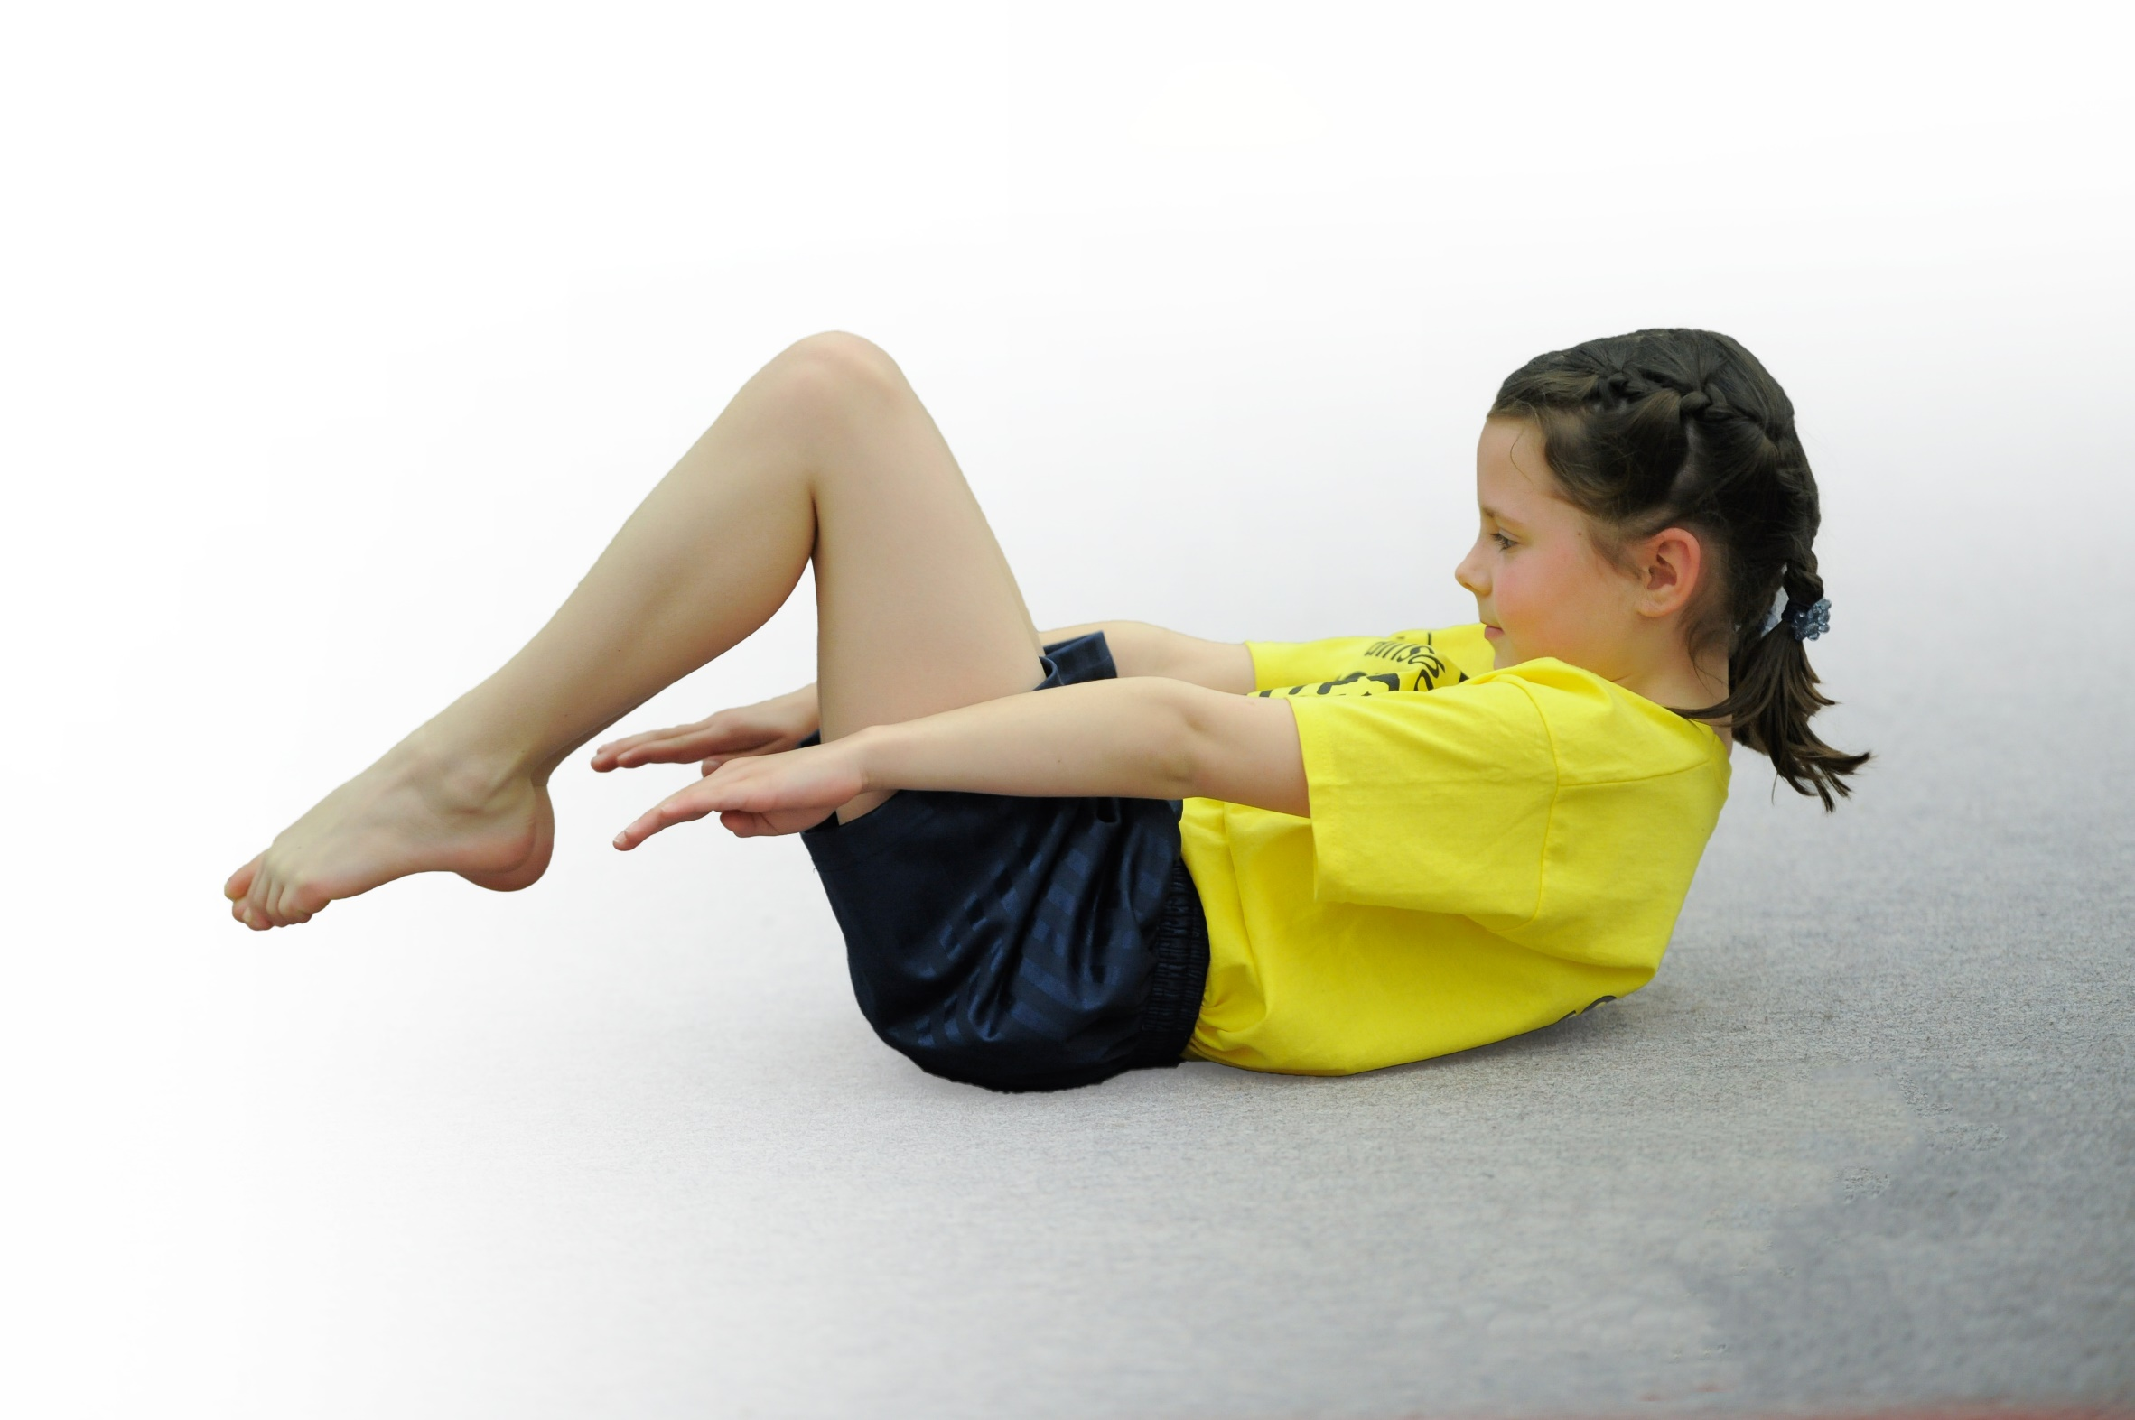build capacity and capability within the school to ensure that improvements made now will benefit pupils joining the school in future years

Please visit [gov.uk](https://www.gov.uk/guidance/pe-and-sport-premium-for-primary-schools) for the revised DfE guidance including the 5 key indicators across which schools should demonstrate an improvement. This document will help you to review your provision and to report your spend. DfE encourages schools to use this template as an effective way of meeting the reporting requirements of the Primary PE and Sport Premium.

We recommend you start by reflecting on the impact of current provision and reviewing the previous spend.

Under the [Ofsted Schools Inspection Framework](https://www.gov.uk/government/publications/school-inspection-handbook-from-september-2015), inspectors will assess how effectively leaders use

the Primary PE and Sport Premium and measure its impact on outcomes for pupils, and how effectively [governors](https://www.gov.uk/government/publications/governance-handbook) hold them to account

for this.

Schools are required to [publish details](https://www.gov.uk/guidance/what-maintained-schools-must-publish-online#pe-and-sport-premium-for-primary-schools) of how they spend this funding as well as on the impact it has on pupils’ PE

and sport participation and attainment.

We recommend regularly updating the table and

publishing it on your website as evidence

of your ongoing review into how you are using the money

to secure maximum, sustainable impact. To see an example of how to complete the table please click [HERE](http://www.afpe.org.uk/physical-education/wp-content/uploads/Template-Exemplification.pdf).

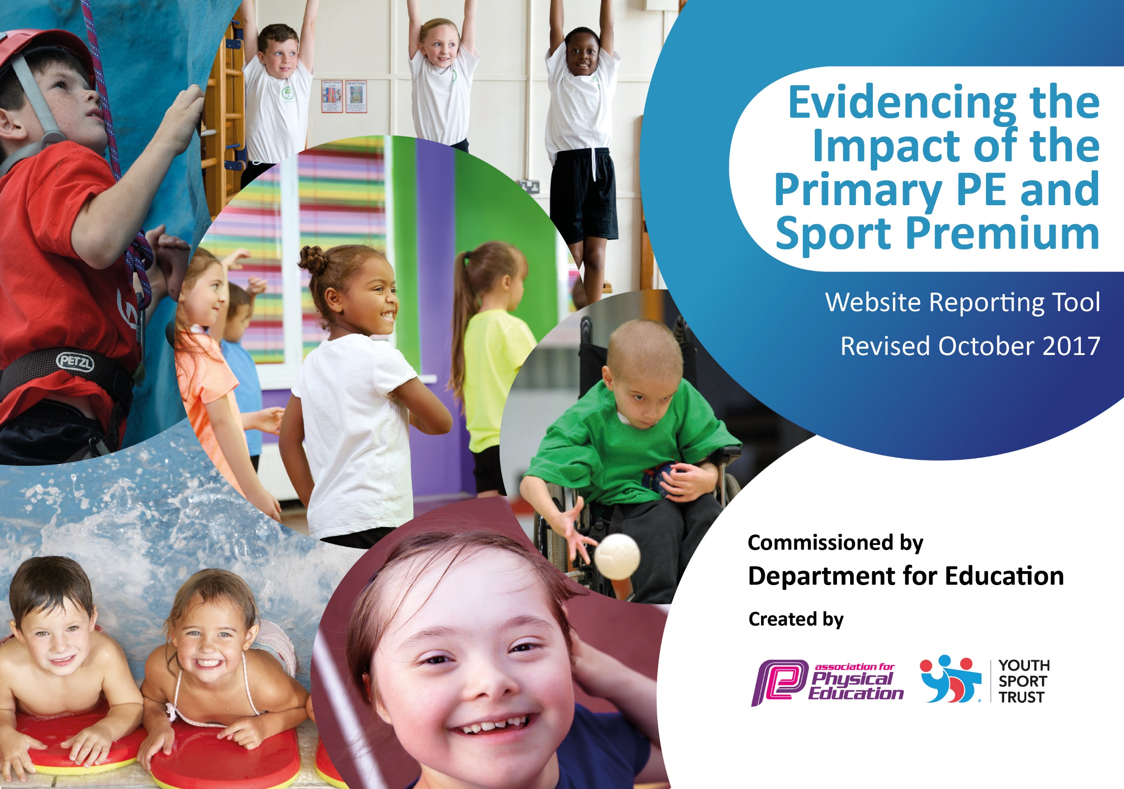

Support for review and reflection - considering the 5 key indicators from DfE, what development needs are a priority for your setting and your students now and why? Use the space below to reflect on previous spend, identify current need and priorities for the future.

|  |  |
| --- | --- |
| Key achievements to date: | Areas for further improvement and baseline evidence of need: |
| Most staff have received full training for TLG-PE and the CPD is continuous and evolving.  Structured active sessions are offered to all children at lunchtime.  After school clubs and Breakfast Clubs have successfully restarted.  Physical Education enrichment activities will now take place again in 2022/23.  All Year 1 and 2 children will take part in at least 1 inter-school competition Reception, Year 1 and Year 2 all take part in 1 festival per year.  Steps 2 Summit has been relaunched for daily activity. | Teaching of TLG-PE will be monitored by the PE Leader to ensure it is having maximum impact on children’s physical development.  Ensure Steps 2 Summit is used to raise and monitor activity levels of all children.  Introduce the idea of competition to the children through simple daily 1 minute challenges. |

|  |  |
| --- | --- |
| Meeting national curriculum requirements for swimming and water safety | Please complete all of the below: |
| What percentage of your Year 6 pupils could swim competently, confidently and proficiently over a distance of at least 25 metres when they left your primary school at the end of last academic year? | n/a – infant school only |
| What percentage of your Year 6 pupils could use a range of strokes effectively [for example, front crawl, backstroke and breaststroke] when they left your primary school at the end of last academic year? | n/a – infant school only |
| What percentage of your Year 6 pupils could perform safe self-rescue in different water-based situations when they left your primary school at the end of last academic year? | n/a – infant school only |
| Schools can choose to use the Primary PE and Sport Premium to provide additional provision for swimming but this must be for activity **over and above** the national curriculum requirements. Have you used it in this way? | No |
|  | |

**Action Plan and Budget Tracking**

Capture your intended annual spend against the 5 key indicators. Clarify the success criteria and evidence of impact that you intend to measure to evaluate for students today and for the future.

|  |  |  |  |  |
| --- | --- | --- | --- | --- |
| **Academic Year:** 2022/23 | **Total fund allocated:** £17,200 | **Date Updated:** | |  |
| **Key indicator 1:** The engagement of all pupils in regular physical activity – Chief Medical Officer guidelines recommend that primary school children undertake at least 30 minutes of physical activity a day in school | | | | Percentage of total allocation: |
| % |
| School focus with clarity on intended **impact on pupils**: | Actions to achieve: | Funding allocated: | Evidence and impact: | Sustainability and suggested next steps: |
| Ensure a large percentage of KS1 pupils are physically active at lunchtime. This will help more children reach the Chief Medical Officer’s target of 60 minutes a day for children over 5 years old.  Re-focus staff on Steps 2 Summit daily activity programme across Reception and Key Stage One. | Meet with lunchtime sports coach/play leader to discuss which lunchtime activities to offer and how we can meet the needs of all children ensuring physical needs are met after the lockdown.  Remind staff of how to use Steps 2 Summit and train new staff.  Complete Steps 2 Summit display in hall. | £2500  Included in subscription for TLG-PE. | Coach was in school three days a week all year. Activities were discussed with PE lead and children were targeted in year groups. A reasonable percentage took part.  Still struggling to engage staff with this so needs a further relaunch on the importance of daily activity for all pupils. | We are looking to move to a Playleader in 23/24 rather than a coach. This will save money and also address different needs. The emphasis will be on physical activity rather than sport.  Re-launch Steps 2 Summit with assemblies and a whole school competition. |
| **Key indicator 2:** The profile of PE and sport being raised across the school as a tool for whole school improvement | | | |  |
| School focus with clarity on intended **impact on pupils**: | Actions to achieve: | Funding allocated: | Evidence and impact: | Sustainability and suggested next steps: |
| Raise the profile of PE, School Sport and activity in a range of ways – CPD for all staff, Curriculum Support for 6 weeks, PE Co-ordinator meetings 3 times a year, KS1 competitions, After School/Breakfast Clubs, Reception and KS1 festivals, Midday Supervisor training. | All classes to attend 1 festival and Key Stage 1 classes at least 1 competition during the year. | £1750 (package affiliation) | Children had great enthusiasm for attending these events after so long without being able to take part.  They created a ‘buzz’ about PE and School Sport again. | Events will take place again next year and children will attend. Consider a PE/sport newsletter in 2023/24 to report these to parents so they have more awareness of what the school is doing to raise the profile of sport and activity. |

|  |  |  |  |  |
| --- | --- | --- | --- | --- |
| **Key indicator 3:** Increased confidence, knowledge and skills of all staff in teaching PE and sport | | | | Percentage of total allocation: |
| % |
| School focus with clarity on intended  **impact on pupils**: | Actions to achieve: | Funding  allocated: | Evidence and impact: | Sustainability and suggested  next steps: |
| Purchase subscription with TLG-PE. This will provide a creative, inclusive, skills based curriculum for all pupils from YR-Y2. It will include CPD for all staff to enable them to deliver and assess the PE curriculum to ensure sustainability for the future. It will support the PE lead in all areas of the role including quality of teaching and learning, measurement of impact and funding compliance. They will also work with Senior Leaders and Governors to ensure they understand their role in Physical Education. | Meetings when necessary with Colin from TLG PE to discuss any updates.  Update pupil data to the TLG system to allow for accurate assessment.  Half termly monitoring/training visits from TLG-PE to ensure the programme is being implemented correctly and there has been an impact on the teaching of PE and an increase in staff subject knowledge.  Regular monitoring of PE assessments and judgements in all year groups. | £3750 subscription to the project | Colin continues to provide regular CPD for staff where necessary.  Further needs will be identified and addressed in the most appropriate and useful way.  This will ensure that all children receive a high quality PE education allowing for carefully planned skill progression. | Three years subscription to TLG-PE has been purchased while funds are available to ensure consistency in teaching in years to come. |
| **Key indicator 4:** Broader experience of a range of sports and activities offered to all pupils | | | | Percentage of total allocation: |
| % |
| School focus with clarity on intended  **impact on pupils:** | Actions to achieve: | Funding  allocated: | Evidence and impact: | Sustainability and suggested  next steps: |
| Ensure pupils are given the opportunity to try new sports during PE lessons. This will enable children to foster an enjoyment of a wider range of activities and discover new skills and talents.  Provide all KS1 children with an opportunity to experience a sport with an element of risk.  This will raise self-esteem and confidence. Children will then transfer their improved growth mindset to other areas of the curriculum. | One block planned at present with ESSP – Gymnastics.  Research trip to new Sky Trail at West Park for all Y1 children and Canoeing at Conkers for all Y2 children. | Included in ESSP subscription  £1100 | Children showed great enthusiasm and enjoyment for the Gymnastics sessions. Links were made to locals clubs for children showing interest/promise. Staff were able to learn from the sessions to improve their own confidence in the teaching of Gymnastics.  Sky Trail was not possible, Y1 did not complete an activity so will do something Autumn 23 if requested.  Y2 had a trip to Ninja Warrior as an exciting way to start the year and get to know their new class. | A different activity will be selected in 23/24 to ensure a wide variety.  Y2 gained a lot from visiting Ninja Warrior as a start of the year activity. They were able to test their physical skills but also staff noticed an increase in self-esteem from some of the less able children and also a real sense of achievement. It developed friendships and teamwork within the class. |
| **Key indicator 5:** Increased participation in competitive sport | | | | Percentage of total allocation: |
| % |
| School focus with clarity on intended  **impact on pupils**: | Actions to achieve: | Funding  allocated: | Evidence and impact: | Sustainability and suggested  next steps: |
| Ensure all KS1 pupils participate in at least 1 competition during the year.  This will develop the skills children need to participate in competition – dealing with winning/losing, how to maximize performance etc.  This also ensures the National Curriculum area of taking part in competitive sport is addressed. | Attend competitions provided by ESSP. | (competitions included in ESSP package) | All KS1 pupils took part in the Cross Country event at the local secondary school.  This was enjoyed by many children and for some it required a real test of their resilience. | This cross country event will take place again next year and children will attend. Next year this will be reported to parents so they have more awareness of what the school is doing to raise the profile of sport and activity. |