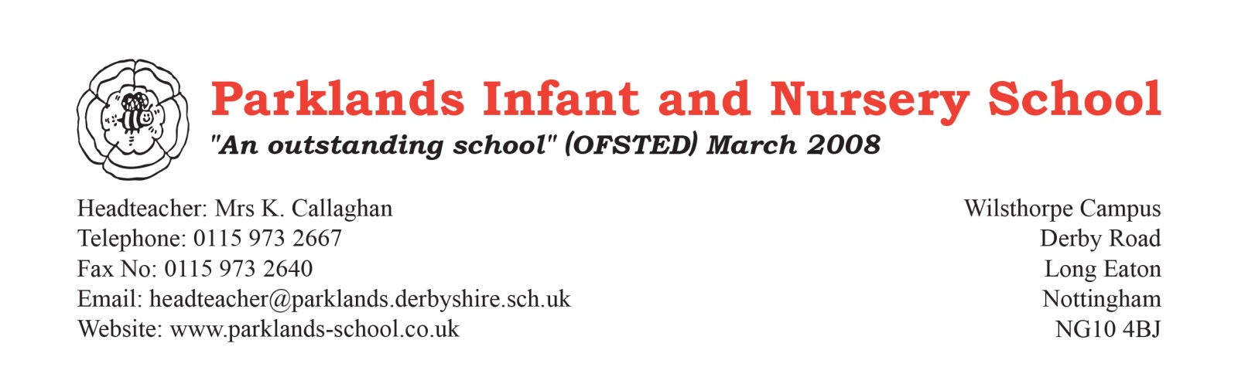

Re: New Scheme of Learning – PSHE/RSHE

Dear Parents/Carers,

From September 2026, we will be introducing a new PSHE and RSHE scheme of learning for children from Early Years to Year 2. The scheme is called 1decision, and more information for parents and carers can be found here:

Parent/carer Zone: RSHE and PSHE Support and Guidance

Within the Primary PSHE and RSHE curriculum, we cover a wide range of important areas, including:

● Keeping/Staying Safe
● Keeping/Staying Healthy
● Relationships
● Growing & Changing
● Being Responsible
● Feelings & Emotions
● Computer Safety
● Our World / The Working World
● Hazard Watch
● A World Without Judgement
● Fire Safety
● Personal Safety

The information below provides an overview of our approach to PSHE and RSHE and some of the key messages your child will receive.

Introduction

In this letter, we use the term “parents and carers” to include all adults with a caring role for a child. However, we recognise and value the important role that grandparents, aunties, uncles, and older siblings can play in supporting conversations about relationships. You may wish to share this information with those key people in your family.

Since September 2020, Relationships, Sex and Health Education (RSHE) has been statutory in all primary schools. This means all schools are required by the government to teach these topics, just as they do English and Maths.

In primary schools, sex education is not compulsory, however, the Department for Education (DfE) strongly advises that schools continue to deliver some elements of sex education to ensure that children have the skills to develop positive and healthy relationships in adolescence, whilst also understanding how to keep themselves safe from harm. As an infant school, we will not be teaching any elements of sex education.

The 1decision Scheme

We have reviewed the scheme from Early Years to Year 2 and you can be reassured that this programme of videos, worksheets and interactive activities has been sensitively developed to teach children about relationships using an age-appropriate and sequential approach. If you would like to view these resources, please look on the school website for topic knowledge overviews and the RSHE policy.

Delivering RSHE with 1decision

Early Years Foundation Stage (EYFS)

1decision resources use colourful animated storybooks to start conversations around feelings and emotions with our youngest learners.

Key Stage 1

Children begin to learn about appropriate touch and how to keep themselves safe. In Year 1 or 2, pupils are taught the correct names for external genitalia, as this is a requirement of the national curriculum for science. You may hear your child use words such as penis, vulva, or vagina.

Although you may use family-specific terms at home, it’s crucial that school staff understand children clearly, particularly when safeguarding concerns arise. For instance, if a child uses terms like “cookie” or “fairy,” serious concerns could be misunderstood or missed.

You can support us by using the correct terminology at home and reinforcing which areas of the body are private. In school, we also use the NSPCC Talk PANTS resource, which you can access for free here:

Talk PANTS: Conversation to help keep children safe | NSPCC

The Sex Education element of RSHE is not taught within our infant school year groups. Should a member of staff, however, be asked a direct question about sexual relationships, they will try to give a simple and honest answer, using their professional judgement and discretion, and taking account of the age of the child. The member of staff will share the conversation with the child’s parents as appropriate.

The RSHE taught at Parklands is made up of statutory elements from Relationships Education and Health Education. These include: positive family relationships, caring friendships and keeping safe and healthy, including mental well-being and online safety and how to respond to bullying. This is done through a series of videos, quizzes and other interactive activities.

There is no right to withdraw from Relationships Education or Health Education. As the children progress beyond Year 2, once they have left our school, some RSHE lessons begin to link to the science curriculum introducing Sex Education. At this later stage, parents have the right to request their child to be withdrawn from the Sex Education elements within RSHE that are additional to the science curriculum.

Want to Know More?

We understand that parents may have questions. We encourage you to:

● Visit the 1decision Parent/Carer Zone: RSHE and PSHE Support and Guidance

● Review curriculum overviews and our RSHE policy on the school website (available from September)

● Speak to your child’s class teacher if you have any further questions

Thank you for your continued support. We look forward to introducing this new programme and supporting pupils’ learning and personal development throughout their time in primary school.

Kind regards

Mrs A Etchells
Pastoral Lead and PSHE/RSHE Lead

