PARKLANDS INFANT AND
NURSERY SCHOOL



SCHOOL ATTENDANCE AND LEAVE OF
ABSENCE POLICY

Approved by the Governing Body of Parklands Infant & Nursery School
Date: Tuesday 24th March 2026
Signed: ____________________________
Mrs S Evitts (Chair of Governors)

PARKLANDS INFANT AND NURSERY SCHOOL
SCHOOL ABSENCE /LEAVE OF ABSENCE POLICY

School Attendance Policy

1. Rationale
Parklands Infant and Nursery School is committed to raising attainment and attendance. Central to raising standards in education and ensuring all pupils can fulfil their potential is the need for pupils to attend school regularly to receive the full benefit from their education. Missing out on lessons leaves children vulnerable to falling behind. Regular school attendance is essential if a child is to make the most of the educational opportunity available to them. Children with poor attendance tend to achieve less in both primary and secondary school.
All children of compulsory school age have the right to an efficient full-time education, regardless of age, aptitude, ability and any special needs they may have. Parklands Infant and Nursery School takes its responsibility to monitor and promote the regular attendance of all its pupils seriously. We acknowledge that irregular attendance seriously disrupts continuity of learning, undermines educational progress, can lead to underachievement and low attainment and impedes the child’s ability to develop friendship groups within school.
This policy has been developed in consultation with Governors, Teachers, Education Welfare Services and Parents/Carers. It seeks to ensure that all parties involved in the practicalities of school attendance are aware and informed of attendance matters in school and to outline the schools commitment to attendance matters. It details the responsibilities of individuals and groups involved and the procedures in place to promote and monitor pupil attendance.
At Parklands we are committed to:

Maintaining a whole school culture that promotes and raises the awareness of the benefits of attendance.
Promoting good attendance and reducing absence (including persistence absence).
Ensuring every pupil has access to full-time education to which they are entitled, particularly disadvantaged pupils, those with SEND, and those with medical conditions.
Acting early to address patterns of absence.
Promoting a positive and welcoming atmosphere in which pupils feel safe, secure and valued
Raising the awareness of the importance of differentiated and relevant curriculums.
Promoting opportunities to celebrate and reward pupil’s successes and achievements
Ensuring that attendance is monitored effectively and reasons for absences are recorded promptly and consistently.
Creating a school ethos that pupils want to be part of
Meeting the legal requirements set out by Government
Following and developing procedures that enable the school to identify, follow up and record unauthorised absence, patterns of absence and parent/carer condoned absence with effective monitoring and intervention
Consistently recording authorised and unauthorised absences
Developing a range of effective strategies to follow up intermittent and long term absenteeism and promote good attendance
Monitoring and analysing attendance data to pre-empt any potential attendance concerns.
Encouraging open communication channels between home and school
Ensuring procedures for the reintegration of long term absentees are effective

At Parklands we will:
We will:
Expect: expect there to be a commitment from all to improving school attendance
Report: report and follow up any absence immediately
Monitor: monitor absences, patterns of absences using data
Record: begin to build up a chronology as soon as attendance issues are raised Listen and understand: Listen to parents/carers and understand the issues.
Facilitate support: Work with the parents/carers to overcome barriers to attendance.
Formalise support: work with parents/carers to set up an action plan of intervention and support.
Enforce: If there is no improvement, proceed with legal enforcement, and/or referral to Children’s Services.

At Parklands we expect parents and carers to:
Perform their legal duty by ensuring their children of compulsory school age who are registered at school to attend regularly.
Ensure their child is punctual to school properly dressed, with the right equipment and in a condition to learn. A reason should be offered for any lateness.
Keep requests for their child to be absent to a minimum and only under “exceptional/medical circumstances”.
Try their best to arrange medical appointments out of school hours.
Offer a reason for any period of absence, preferably before the absence or on the first day of absence.
Work closely with the school and/or Education Welfare to resolve any problems that may impede a child’s attendance.
Take family holidays during school holiday periods, be aware that requests for holidays during term time will be refused except in exceptional circumstances and be aware that penalty notices may be issued for unauthorised holidays.
Support their child and recognise their successes and achievements.
Parents/Carers have a legal duty to make sure that their child aged 5-16, if registered at a school, attends regularly. If a child of compulsory school age fails to attend regularly at the school at which they are registered or at a place where alternative provision is provided for them, the parents/carers may be guilty of an offence and can be prosecuted by the local authority’s education welfare services. Education welfare services conduct all investigations in accordance with the Police and Criminal Evidence (PACE) Act 1984.
If a child is in the care of foster parents, special/legal guardianship, or in a residential home, it is important that the carers recognise their parenting role where attendance to school is concerned. They will be supported by close co-operation between the school, education welfare services and the social services where such a child’s attendance is irregular.
The local authority has the power to prosecute parents who fail to comply with a School Attendance Order (section 442 of the Education Act 1996) or fail to ensure their child`s regular attendance at school (section 444 of the Education Act 1996).
As an infant and nursery school we recognise that all absenteeism is parent/carer condoned due to the age of the children. Where this is believed or found to be without reasonable justification, and a regular occurrence, the school will treat this as a safeguarding concern and may refer to Children’s Services in line with escalation policies and the local authority threshold.

At Parklands we expect all pupils to:
Respect themselves and others and realise that everyone is important
Do all they can to attend school regularly and punctually
Inform a trusted adult if they feel unsafe or feel they are being bullied in any way
Encourage friendship, respect for all, and a sense of belonging
To be happy and encourage others to feel happy

2. Arrival and Registration

Pupils line up and are collected from the playground at 8:55am. The class teacher will take a register recording who is present and absent from school at 9:00am. Any late pupils enter the school through the main entrance. Parents/carers of any pupils arriving late must record the details on a late ‘slip’. This records name, class, time and reason for lateness.
All staff need to be aware that any child arriving late MUST register at the office for purposes of fire regulations.
The register officially closes at 9.20am and any pupil arriving after this will be marked with a U code which indicates that the child arrived after the registers have closed, this is classed as an unauthorised absence. The afternoon session begins at 1.00pm and the register is again taken at these times. Each day counts as two attendance sessions.

3. Illness and Medical Appointments
- Please arrange medical appointments outside school hours whenever possible.
- Where a medical appointment is unavoidable during the school day, this must be recorded on the appropriate form by parents/carers. If a child must leave school, they should return immediately after the appointment. Evidence may be requested.
- All children arriving or leaving outside normal hours must be signed in/out at the school office for safeguarding and emergency purposes.
- Parents must inform the school on the first morning of illness and on each subsequent day of absence if necessary (office staff will inform parents/carers where this isn’t necessary eg: 48 hours for a sickness bug).

4. Definitions

Authorised Absence
A period away from school for a legitimate reason, accepted by the school.
Only the school—not parents—can authorise an absence.

Unauthorised Absence
Absences without permission from the Headteacher (e.g., holidays or outings taken without authorisation).

5. Procedure When a Child Is Absent
- Teachers record all absences in the register.
- If no message is received, the office will attempt to contact parents/carers.
- Parents must phone the school by 9:00 a.m. stating the reason for absence.
- Any uncertainty about a child’s whereabouts will be followed up immediately.

6. Leave of Absence (Including Holidays)
Since September 2013, Headteachers may only grant leave during term time in exceptional circumstances.
- Requests must be submitted on a Leave of Absence form at least two school weeks in advance.
- Written authorisation must be received before the child is absent.
- Unauthorised term-time leave of 5 days or more may result in a Penalty Notice.
- Unauthorised leave is marked with the attendance code G.

Penalty Notice Charges
With the introduction of the new National Framework for penalty notices, changes came into force for penalty notice fines from 19th August 2024. The new penalty notice fines are more severe to reflect the Government’s stance on this. monitoring is on a 3-year basis. Please refer to the details below:
Per parent, per child:
Penalty notices will be issued to each parent, for each child absent. For example: 3 siblings absent for term time leave would result in each parent receiving 3 separate fines.
5 consecutive days of term-time leave
Penalty notice fines will be issued for term time leave of 5 or more consecutive days.
10 sessions of unauthorised absence in a 10 week period
Penalty notice fines will be considered when there have been 10 sessions of unauthorised absence in a 10 week period.
First offence:
The first time a penalty notice is issued for term time leave or irregular attendance is £160 per parent, per child paid within 28 days – reduced to £80 per parent, per child if paid within 21 days.
Second offence (within 3 years)
The second time a penalty notice is issued for term time leave or irregular attendance is £160 per parent, per child paid within 28 days.
Third offence and any further offences (within 3 years)
The third time an offence if committed for term time leave or irregular attendance a penalty notice will not be issued and the case will be presented straight to the Magistrates’ Court. Magistrates’ fines can be up to £2500 per parent, per child. Cases found guilty in Magistrates’ Court can show on the parents’ future DBS certificate due to ‘failure to safeguard a child’s education.’
Parklands Infant and Nursery School have adopted the local authority’s Penalty Notice Code of Practice meaning that we can request that the local authority issue penalty notices for unauthorised absences for leave for the purpose of a family holiday that have not been approved, or for persistent absenteeism (without valid medical reason).

7. Long-Term Absence
For illness lasting more than five days, the school can provide work for completion at home.
8. Repeated Unauthorised Absence
- Unauthorised absence is recorded and reported to the Local Authority.
- Attendance and punctuality are closely monitored.
- Parents may be invited to meetings or receive home visits if concerns continue.
- Legal action may be considered for persistent non-attendance.

9. Children Missing from Education
- If a child is absent with no explanation, the school will conduct appropriate checks.
- By day 11 of continuous unauthorised absence, the Local Authority is notified.

10. Rewards for Good Attendance
Strategies used at Parklands to promote good attendance and punctuality
- Staff will ensure that the curriculum is delivered within a culture of inclusion and in such a way that pupils feel that they have and can succeed.
- Build strong relationships with families.
- The parents/carers of pupils whose attendance has been a cause for concern will be encouraged to set and achieve attendance goals for their child/children.
- Accurately complete attendance registers and have effective procedures in place to follow up absence immediately.
- Pupil attendance figures will be published with the termly and annual academic reports.
- Positive verbal reinforcement is given to pupils who have been absent from school for a period of time and an education action plan developed to help them catch up with any missed curriculum and promote future attendance if necessary.
- Attendance is discussed at parent/pupil consultations where necessary
- Weekly class attendance cups presented in assembly for the highest attendance, ClassDojo message to all parents/carers to inform them who has won.
- End of term class treat for the class with the highest attendance
- Headteacher certificates and stickers for 100% term attendance and for 100% year attendance. Smaller certificates for those with good attendance (95%-99%)
- Regular support from EHP for parents/carers to overcome barriers to attendance.
- Parents/Carers invited to Attendance Celebration Assemblies to see their child presented with their attendance certificate.
- Individual improved attendance will be recognised and praised.

11. Attendance Targets
Targets are set annually with senior leaders, the Governing Body, and the LA School Improvement Partner.
The Headteacher reports attendance data to Governors each term.

12. Monitoring & Review
- Governors monitor overall school attendance and ensure this policy is implemented.
- Teachers monitor class attendance daily and alert the office to concerns.
- Individual pupils with 95% or below are monitored weekly by the Headteacher.
- Half-termly reviews examine individual attendance of all pupils with 94.9% or lower. An audit is carried out and actions decided: below 93% receive a parental responsibility letter and in some occasions a telephone call from the Early Help Practitioner. Below 90% requires all of the above and a potential attendance review if no improvement is seen. If no/little improvement is seen after an attendance review a referral to County Hall can be made.
- Half-termly reviews examine whole-school, class, and pupil-group attendance.

13. Safeguarding Statement
Staff are committed to providing a safe, supportive environment that fosters every child’s development.
We safeguard children by:
- Following rigorous child protection procedures
- Sharing relevant information with parents, staff, and agencies
- Maintaining a culture that prioritises children’s welfare

Appendix A
Attendance codes
- set of standard codes are used consistently within the register. These codes are input into the electronic register as required and are used to give depth of meaning to the register and provide statistical meaning to the absences.
Code School Meaning Statistical Meaning Physical Meaning
/ Present (AM) Present In for whole session
\ Present (PM) Present In for whole session
- Educated off site (Not dual registration) Approved Educational Activity Out for whole session
- Other authorised circumstances Authorised Absence Out for whole session
- Dual registration Present Out for whole session
- Excluded no alternative provision
- Unauthorised Family holiday (not agreed) Unauthorised Absence Out for whole session
- Family holiday (agreed) Authorised Absence Out for whole session
- Illness(not med/dental etc. appointments) Authorised Absence Out for whole session
- Interview Approved Educational Activity Out for whole session
- Late (before reg closed) Present Late for session
- Medical/Dental appointments Authorised Absence Out for whole session
- No reason yet provided for absence Unauthorised Absence Out for whole session
- Unauthorised absence (Failure to notify School) Unauthorised Absence Out for whole session
- Approved sporting activity Present Out for whole session
- Religious observance Authorised Absence Out for whole session
- Study leave Approved Educational Activity Out for whole session
- Traveller absence Authorised Absence Out for whole session
- Late( after registers closed) Unauthorised absence Late for session
- Educational visit or trip Approved Educational Activity Out for whole session
- Work experience Approved Educational Activity Out for whole session
- Non-compulsory school age absence
- Unable to attend due to exceptional circumstances
# School closed to pupils and staff Attendance not required Out for whole session
* DfES Z: Pupil not on roll Attendance not required Out for whole session

Appendix B
Procedure for proceeding with issuing a penalty notice in the case of persistent absenteeism

Attendance concern raised

Significant improvement made,

track as usual

Appropriate notice of attendance issue letter sent to parents/carers

Little/no
improvement/decline

Support put in place, begin to build chronology

Little/no improvement/decline

Issue Parental Responsibility letter

Little/no improvement/decline

Issue Warning letter, begin monitoring period (20
-
30
days
)

Less than 90% attendance in this period, penalty notice issued

Fine unpaid, escalated to court proceedings

School gather

witness statements from all involved in support efforts

Significant improvement
during monitoring period,

track as usual

Decline after monitoring period

-

Appendix C
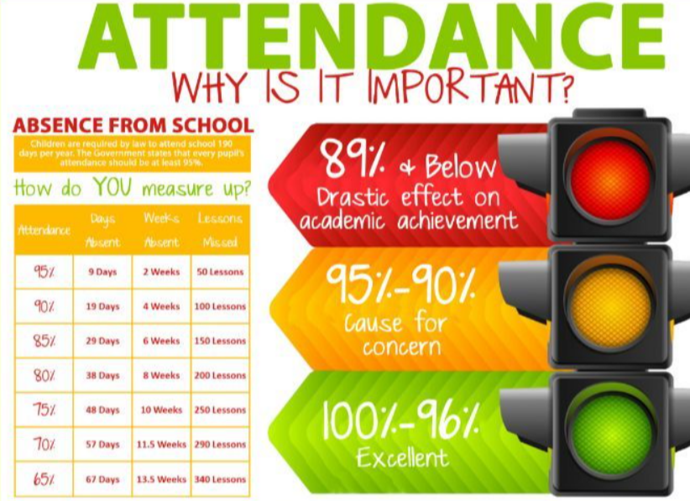

Appendix C


