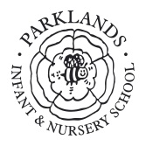
Year 2 Class Information - Autumn Term 1 2025

Dear Parents and Carers
Welcome back to a new school year and we hope you have had a great summer with your families! The children have settled well into their new classes, and the children are ready to fill their brains with knowledge! We are pleased to be joined by Mrs Barker who will be supporting us across Year 2. We are also fortunate that Mrs Smith, Mrs Nassau and Mrs Johns will be supporting of us. On a Tuesday afternoon, Mrs Barker will be teaching Class 6 to cover teacher preparation time. This newsletter is to provide you with further information about Year 2 and what the children will be doing over the coming half term.
REMINDER

Please remember to provide your child with a named water bottle every day. Each child needs a full, clearly labelled PE kit in school at all times. We recommend that your child has a pair of warm tracksuit bottoms or leggings for the cooler months. Although we have set days for PE, there are sometimes special occasions where the kits are required.

HOMEWORK

Please share your child’s reading book with them at home and write in their reading diary so we know they have read with you at home. We can’t emphasise strongly enough how this time supports your child in all of their learning.
Homework will be provided via ClassDojo- please keep a look out!



Parklands person

This half term we will be helping the children to think about how they can be a Respectful Parklands Person. This will be discussed in class, in assemblies and as part of our PSHE (personal, social and healthy education) work. Please ask your child what they are doing to become a Respectful Parklands Person!

Please do speak to us before or after school if convenient, telephone the office, or you may contact us through ClassDojo.

Please note, our topic celebration will take place on Tuesday 21st October at 2:45pm- further details to follow!

Many thanks for your continued support. As ever, please do come and speak to us if you have any questions or concerns.
The Year 2 Team


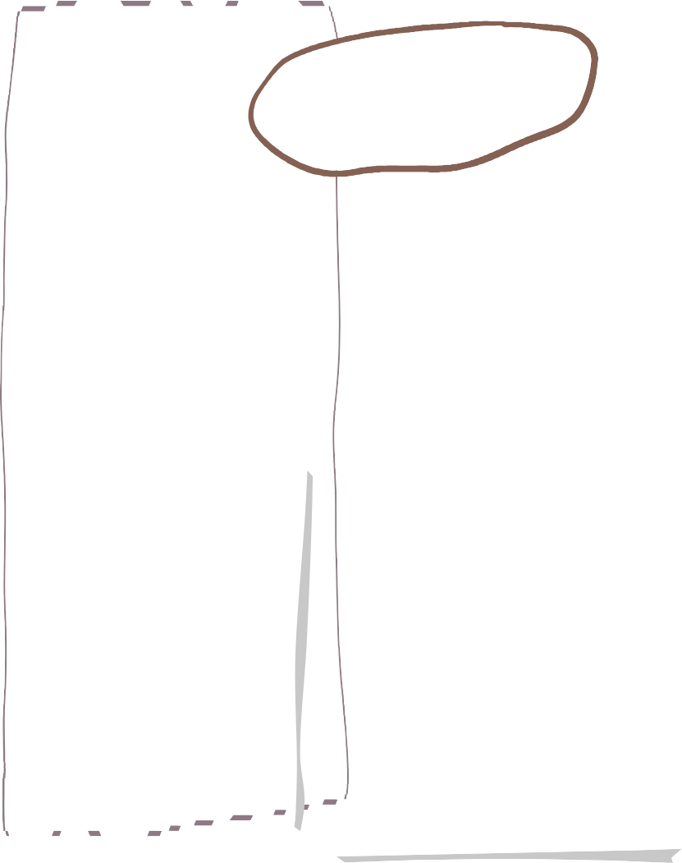


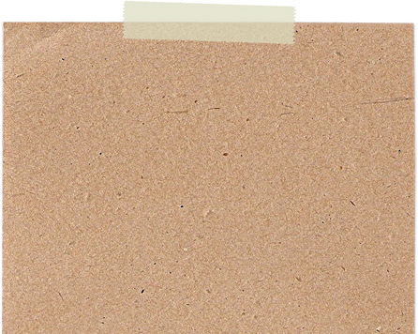


Autumn One in Year 2
Science
English
Maths

English lessons
In our English lessons will read the book Troll Swap.
Our end of unit writing focus will be to write a story based on Troll Swap with the children’s ideas for new characters.
We main objectives will be:
• Use punctuation correctly – full stops, capital letters.
• Use expanded noun phrases to describe and specify.
• Use subordination (because) and coordination (and) to join ideas.

We are reading…
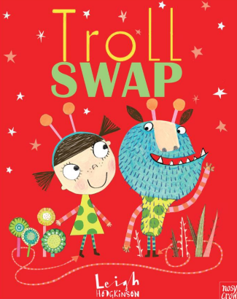
This half term we will be focussing on learning the place value of numbers up to 100 (this means exploring what numbers are made up of).
This will involve learning how many tens and ones are in digits, adding numbers together to find the total, as well as placing numbers on number lines in the correct order. Children will also practise their problem solving and reasoning skills by exploring puzzles and problems.
We will be learning about animals and their habitats. We will look at habitats in our local area and some around the world. We will then look at micro habitats and why animals choose specific habitats. Then we will find out how animals get their food including looking at food chains.

Phonics
We will be continuing with our daily Read Write Inc lessons. In these lessons the children will learn new sounds and consolidate their prior knowledge. They will learn to read and write words with the new sounds in and read decodable books to improve their fluency and comprehension.

This half term in Art we are learning about Sculptures.
We will learn about a famous sculptor -Andy Goldsworthy. We will use a range of different mediums – clay and natural materials to create our own sculptures.
Art



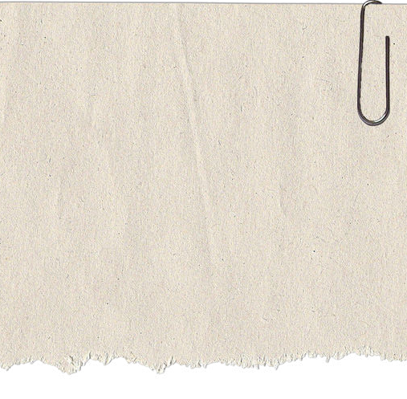

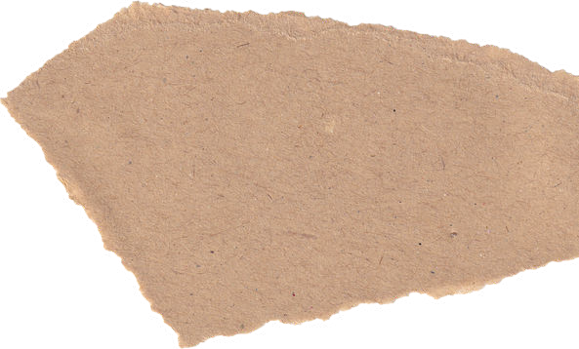


Music
R.E.
History
Our unit is call and response.
The children will learn how to use tempo and dynamics in their piece of music. They will create rhythms and learn a call and response song.
We will be focussing on discrimination. We will find out what discrimination means and then look at famous black people from History. We will learn about their lives and how their actions have changed the world.
Is it possible to be kind to everyone all of the time?
Our focus will be on Christianity.

PE
Computing
How is information technology (IT) being used for good in our lives? The children will explore how IT benefits society in places such as shops, libraries, and hospitals. Whilst discussing the responsible use of technology, and how to make smart choices when using it. The children will learn about online safety too.

Team Building and Fundamentals

The children will learn lots of team building skills such a listening and taking turns. The children will also learn how to correctly sprint, jump and skip.
Our first puzzle piece is ‘Being me in my world’ We will learn about rights and responsibilities and find out about rewards and consequences.
PSHE

