

PARKLANDS INFANT AND NURSERY
SCHOOL

DESIGN &TECHNOLOGY
POLICY

Approved by the Governing Body of Parklands Infant & Nursery School
Date: Tuesday 14th October 2025
Signed: ____________________________
Mrs Sophie Evitts (Chair of Governors)

Parklands Infant and Nursery School
Design and Technology Policy – September 2025

Section 1: Introduction to the Policy Purpose
The purpose of this policy is to describe our practice in Design and Technology, and the principles upon which this is based.

Aims
This policy sets out to ensure consistency in the teaching and learning within Design and Technology across the school. Design and Technology prepares children to deal with tomorrow’s rapidly changing world. It encourages children to become independent, creative problem-solvers and thinkers as individuals and as part of a team - making positive changes to their quality of life. It enables them to identify needs and opportunities and to respond to them by developing a range of ideas and by making products and systems. Through the study of Design and Technology, they combine practical skills with an understanding of aesthetic, social and environmental issues, as well as functions and industrial practices. This allows them to reflect on and evaluate present and past Design and Technology, its uses and its impacts. Design and Technology helps all children to become discriminating and informed future consumers and potential innovators.

This policy supports our school mission statement of: “To establish a life-long love of learning within a caring environment, in which we encourage all children to fulfil their potential through enjoyable and enriching experiences”.

It also supports our whole school ethos of developing the Parklands Person.
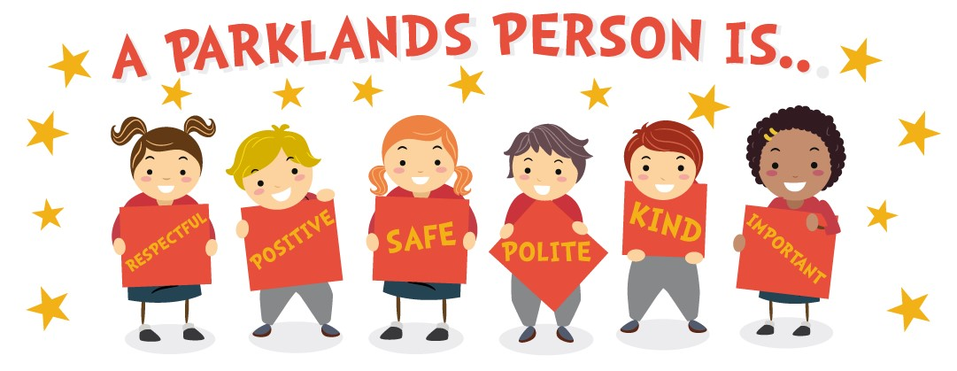

Consultation
The policy was put together by Claire Roseveare in consultation with teaching staff, pupils, parents/carers and school governors.

INTENT
Here at Parklands, Design and Technology is an inspiring, rigorous and practical subject. We encourage children to solve problems creatively, both as individuals and as members of a team. Resilience is a key theme running through our DT curriculum, and the children are encouraged to become innovators and risk-takers. We provide opportunities for children to use their creativity and imagination, and to design and make products that solve real and relevant problems within a variety of contexts. We also aim to make links to designs and designers throughout history, providing opportunities for children to critically reflect upon and evaluate their designs. We aim to link work to other disciplines such as mathematics, science, engineering, computing and art. This gives learning purpose and relevance to the children.

IMPLEMENTATION
Through a variety of creative and practical activities, we teach the knowledge, understanding and skills needed to engage in a sequenced process of designing and making. The children design and create products that consider function and purpose. When designing and making, the children are taught to:

Design:
- use research and develop design criteria to inform the design of innovative, functional, appealing products that are fit for purpose, aimed at particular individuals or groups.
- generate, develop, model and communicate their ideas through discussion, annotated sketches, cross-sectional diagrams, prototypes, pattern pieces and computer-aided design.

Make:
- select from and use a wider range of tools and equipment to perform practical tasks (for example, cutting, shaping, joining and finishing, as well as chopping and slicing) accurately.
- select from and use a wider range of materials, ingredients and components, including construction materials, textiles and ingredients, according to their functional properties, aesthetic qualities and, where appropriate, taste.

Evaluate:
- investigate and analyse a range of existing products.
- evaluate their ideas and products against their own design criteria and consider the views of others to improve their work.
- understand how key events and individuals in design and technology have helped shape the world.

Technical knowledge:
- apply their understanding of how to strengthen, stiffen and reinforce more complex structures.
- understand and use mechanical systems in their products.
- understand and use electrical systems in their products.
- apply their understanding of computing to program, monitor and control their products
- understand some of the ways that food can be processed and the effect of different cooking practices (including baking and grilling).

Key skills and key knowledge for Design and Technology have been mapped across the school to ensure progression between year groups. The context for the children’s work in Design and Technology is also well considered and children learn about real life structures and the purpose of specific examples, as well as developing their skills throughout the programme of study. Design and technology lessons are also taught as a block so that children’s learning is focused throughout each unit of work.

IMPACT

We ensure that children in the EYFS and KS1:

- develop the creative, technical and practical expertise needed to perform everyday tasks confidently and to participate successfully in an increasingly technological world;
- build and apply a repertoire of knowledge, understanding and skills to design and make high-quality prototypes and products for a wide range of users and critique, evaluate and test their ideas and products and the work of others;
- understand and apply the principles of nutrition and learn how to cook. Children will design and make a range of products. A good quality finish will be expected in all design and activities made appropriate to the age and ability of the child.

Children learn how to take risks, becoming resourceful, innovative, enterprising, and capable. Through the evaluation of past and present design and technology, they develop a critical understanding of its impact on daily life and the wider world.

Section 2: Procedures and Practice Roles and Responsibilities
The Design and Technology Lead is responsible for providing an overview of the subject across the school to inform staff planning and to over advice in which the curriculum can be delivered in an effective and engaging way. They should have an up-to-date knowledge of the subject requirements and ensure that these are met across the school, as well as having an overview of assessment. They are responsible for ensuring that an overview of the subject is available on the school website. The Design and Technology Lead also has a sound knowledge of the resources which are available within school and ensures that resources are replenished and updated as necessary. The Design and Technology Lead is responsible for the planning and implementation of any subject specific events which take place in school.

Individual teachers are responsible for the day-to-day planning, delivery and assessment of the Design and Technology curriculum. The relevant governor is responsible for ensuring there is a good professional dialogue with the subject leader throughout the school year.

Section 3: Aspects
SMCS and British Values
We will ensure that these aspects and values are integrated into and fostered through the children’s education in Design and Technology at Parklands.
Spiritual Education
Design and Technology supports spiritual development by allowing children the opportunity to exercise imagination, inspiration, intuition and insight through creativity and risk taking in analysing, designing and manufacturing a range of products. It instils a sense of awe, wonder and mystery when studying the natural world or human achievement. Encouraging creativity allows children to express innermost thoughts and feelings and to reflect and learn from reflection, for example, asking ‘why?’, ‘how?’ and ‘where?’.
Moral education
Design and Technology supports moral development by raising awareness of moral dilemmas and encouraging pupils to value the environment and its natural resources. Children are encouraged to consider the environmental impact of everyday product and become responsible consumers.

Social education
Design and Technology supports social development by providing opportunities to work as a team, recognising others’ strengths and sharing equipment. Design and Technology promotes equality of opportunity and provides an awareness of areas that have gender issues e.g. encouraging girls to use equipment that has been traditionally male dominated.

Cultural Education
Design and Technology supports cultural development by encouraging children to reflect on ingenious products and inventions, the diversity of materials and ways in which design technology can improve the quality of life. It investigates how different cultures have contributed to technology and reflects on products and inventions, the diversity of materials and ways in which design can improve the quality of our lives.

Democracy
All children are able to take part in creative activities, regardless of ethnicity, gender or ability. They have opportunities to be involved in decision making processes regarding their learning and particularly in group activities.
Individual liberty
Design and Technology provides many opportunities for children to make choices and express personal preferences. They can control the direction of their learning in making art and explore subjects and processes of interest to them.
The rule of law
Whilst creativity allows for personal expression, children are taught to use materials and tools with care to ensure the safety of others. They understand the need for compliance with rules to ensure that they are able to work together.
Mutual respect and tolerance.
Children are taught to respect each other, and adults, and to base their behaviour on the
‘Parklands Person’ principles. They learn that everyone is different, but everyone is equally important. We help children to develop their awareness of people’s differences and similarities, and to value the rich diversity of the human race. Creative experiences teach them that there is a wide range of possibilities and there are no right or wrong answers. They learn to evaluate their own and others’ work and respect opinions.

Planning

Teachers are guided by their knowledge of the children’s interests and needs when selecting appropriate subject content. They develop this into challenging and relevant teaching experiences using their professional skills.

Early Years Foundation Stage:
Effective learning builds on and extends what children know and can already do. Our planning is informed by observations made of the children in order to understand and consider their current interests, experiences, development and learning needs.

There are two stages of planning the curriculum:
Long Term Planning
The curriculum in the EYFS is organised through agreed termly themes over the period of the academic year. The Early years outcomes and the schools EYFS long term plan is used as guidance. Design and technology activities are incorporated into each theme through continuous provision and planned ‘skills / design & make’ activities related to the theme.
Short Term / Weekly Planning
Weekly planning for design and technological activities is informed in two ways. Firstly, through ongoing observation of child initiated, adult initiated and adult directed activities both indoors and outdoors. This allows for flexibility in response to individual children’s needs and interests and for revision and modification of plans. It is informed secondly by referring to the objectives in the long term plans.

Key Stage One:
In Key Stage One, History will be planned as part of the Learning Challenge Curriculum. The Progression Document ensures curriculum coverage and progression in Design and Technology. Plans for each year group ensure clearly sequenced learning across all areas of the Design and Technology National Curriculum. Medium term planning is comprised of 4-5 component parts, clearly defined substantive and disciplinary knowledge, and key knowledge for the term.
Weekly planning is the responsibility of the class teacher and will outline the activities that take place within each year group and how knowledge will be taught to ensure children remember more.

Teaching and Learning
Emphasis is on guided discovery through first hand experiences using a variety of materials and processes. Children learn skills which underpin the development of their creativity. They become aware of the work of other artists and craftspeople and are encouraged to talk about their work and their own. They learn to evaluate their work and understand how they can change it if appropriate.
Teaching and Learning in Design and Technology is displayed in our Family Room. Key vocabulary for each area of learning is shared, alongside samples of children’s work and progression across each year group.
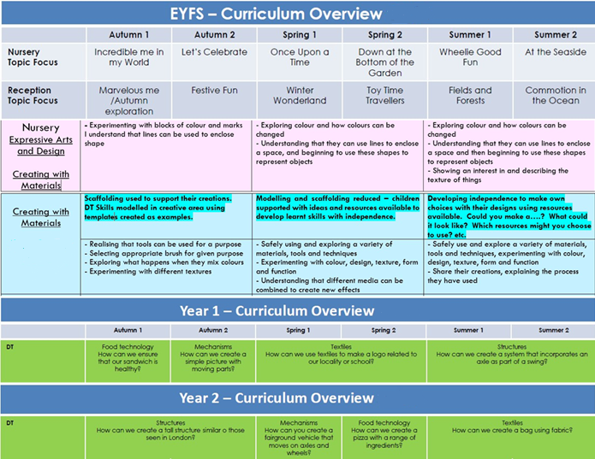

Assessment
Teachers make a termly assessment of children’s performance in Design & Technology. This is recorded on the Foundation Subjects assessment on Insight Tracker. This is analysed by the Design and Technology Lead in order to monitor the performance and progress of pupils in relation the end of year and end of key stage expectations.

EYFS
Assessment is by continuous observation, listening and interaction with the child. Learning is recorded using Tapestry online journals and observations. Throughout the Early Years Foundation stage progress is tracked against the Focus Progression towards the Early Learning Goals, with a specific focus on Expressive Arts & Design. Each child’s experience of the world is different, so the role of the adult is to recognise the need for sensitive intervention to extend their learning appropriately. To encourage self-evaluation and critical appreciation, children are given the opportunity to talk about their work in terms of what they have learnt to do or discovered in the process of making their work.

KS1
Assessment is a continuous process through informal observation and talking with the child to ascertain their understanding. Children can self-evaluate and review their work to allow the opportunity to adapt and develop their ideas. Feedback sheets are completed for each session to identify misconceptions, areas to revisit and to record next steps in learning.

Monitoring
The planning for Design and Technology is reviewed by the DT Lead to ensure coverage and progression and sequenced learning.
Curriculum meetings are held periodically to promote staff awareness and develop their knowledge and skills, to ensure quality of teaching and learning in Design and Technology throughout the school. In addition, observations, work sampling, learning walks and pupil interviews are carried out, which enable the DT Lead to propose developments to enhance teaching and learning. These are planned according to the subject review timetable.

SEND Provision
To make Design and Technology lessons inclusive, teachers need to anticipate what barriers to taking part and learning activities, lessons or a series of lessons may pose for children with particular SEN and/or disabilities. Planning will consider ways of minimising or reducing those barriers so that all children can fully take part and learn. In some activities, children with SEN and/or disabilities will be able to take part in the same way as their peers. In others, some modifications or adjustments will need to be made to include everyone.

Parent/carer Partnership
Parental involvement is encouraged, with attention drawn to activities via newsletters, Tapestry (online journal), information on the website and displays in school. Homework may involve research or practising a particular skill. Parents/ carers are invited to support their children in school, to contribute any particular skills and knowledge they may have in an area being taught. They are invited to class celebrations of work as a culmination of learning throughout the term.

Section 4: Conclusion

Monitoring and Review
The governor with responsibility for Design and Technology is primarily responsible for monitoring the implementation of this policy. This will be through ongoing discussion with the subject lead and consideration of the evidence gathered in the subject file. The governor will report on this to the curriculum committee. The work of the subject lead is also subject to review by the headteacher as part of our performance management arrangements.

Other Documents and Appendices
The Design and Technology policy should be read in conjunction with our policies for curriculum, teaching and learning, assessment, the EYFS, child protection and safeguarding. The writing of this policy has been supported by the National Curriculum, The EYFS Statutory Framework, Development Matters, Focus Progression in Skills (EYFS), Focus Learning Challenge Curriculum and with the support of our local DT Cluster Hub.

This Policy was written by:
Claire Roseveare – EYFS & DT Lead

Governor Approval and Review Dates
The policy is to be reviewed annually.

Governor Approval Date: September 2025
Review Date: September 2026

