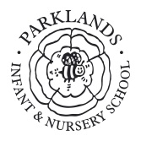

PARKLANDS INFANT AND NURSERY SCHOOL

MUSIC POLICY

Approved by the Governing Body of Parklands Infant & Nursery School

Date: Tuesday 14th October 2025

Signed: ____________________________

Mrs S Evitts (Chair of Governors)

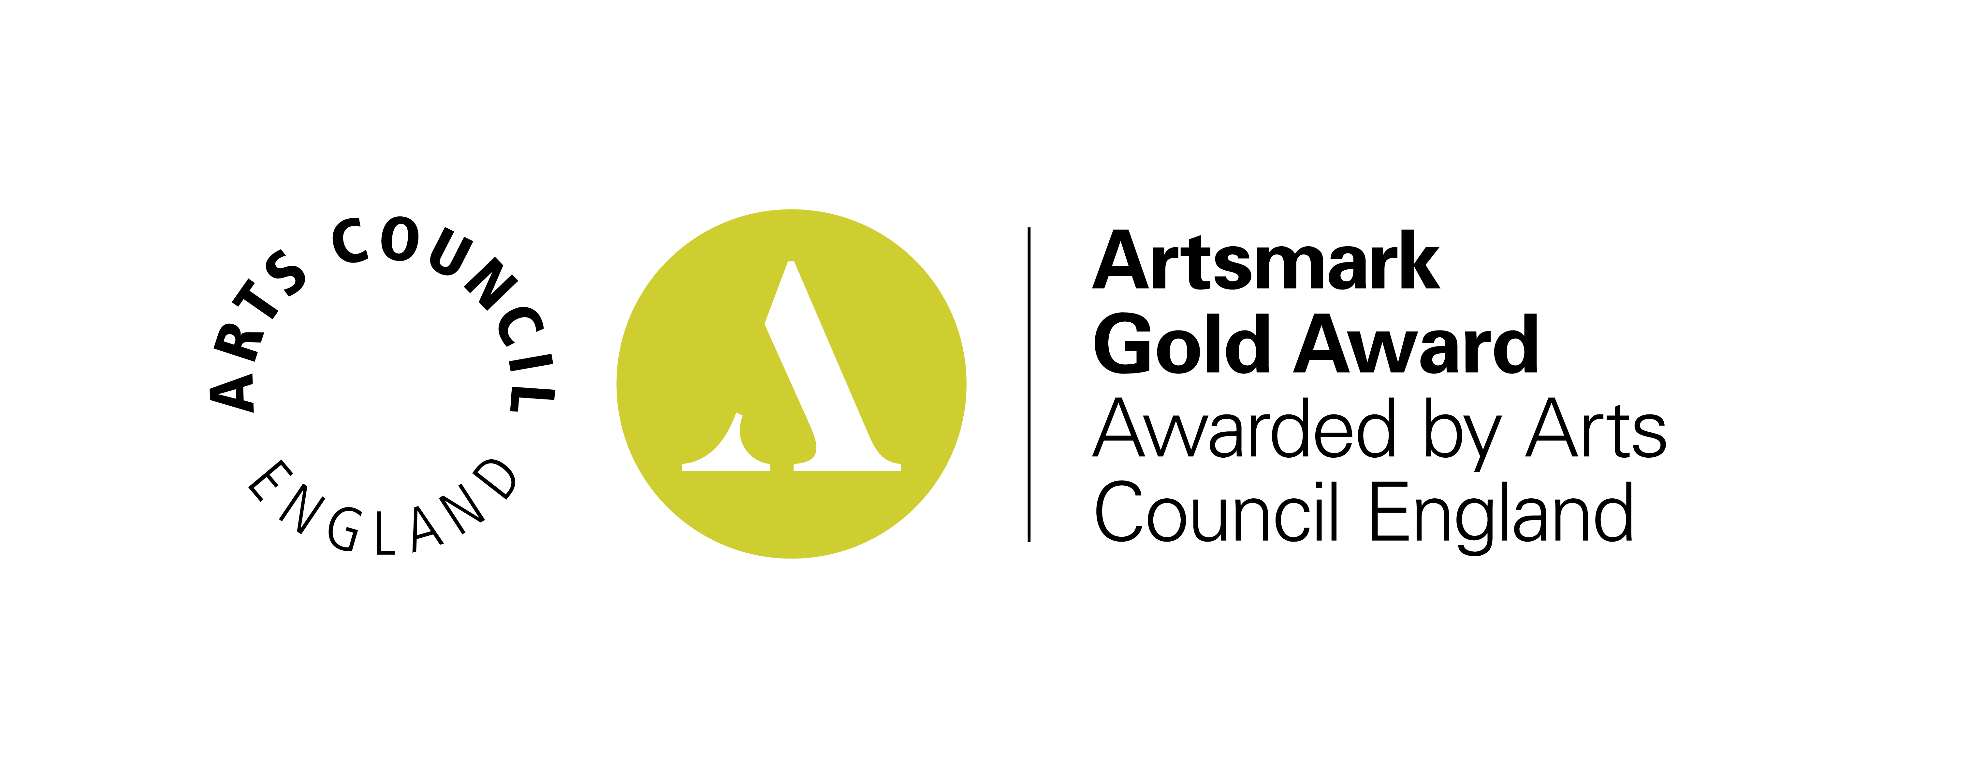

Parklands Infant and Nursery School
Music Policy – October 2025
Section 1: Introduction to the Policy

Purpose
The purpose of this policy is to describe our practice in Music and the principles upon which this is based. The purpose of this policy is to describe our practice in the Arts and the principles upon which this is based. Parklands achieved the Artsmark Gold Award in 2021.

Aims
This policy sets out to ensure consistency in the teaching and learning within Music across the school. This is to ensure that pupils are equipped with the skills to create, play, perform and enjoy music, to appreciate a wide variety of musical forms, and to begin to make judgements about the quality of music.
The aims of teaching music in our school are to enable children to:

- Access a broad music curriculum within the framework of the National Curriculum, which ensures both continuity and progression of learning, and assesses and records achievement
- Develop and express ideas about music from other cultures
- Express opinions about different types of music
- Inspire confidence in creating music
- Find enjoyment in listening to, creating and taking part in musical activities

This policy supports our school mission statement of: “To establish a life-long love of learning within a caring environment, in which we encourage all children to fulfil their potential through enjoyable and enriching experiences”.
It also supports our whole school ethos of developing the Parklands Person.
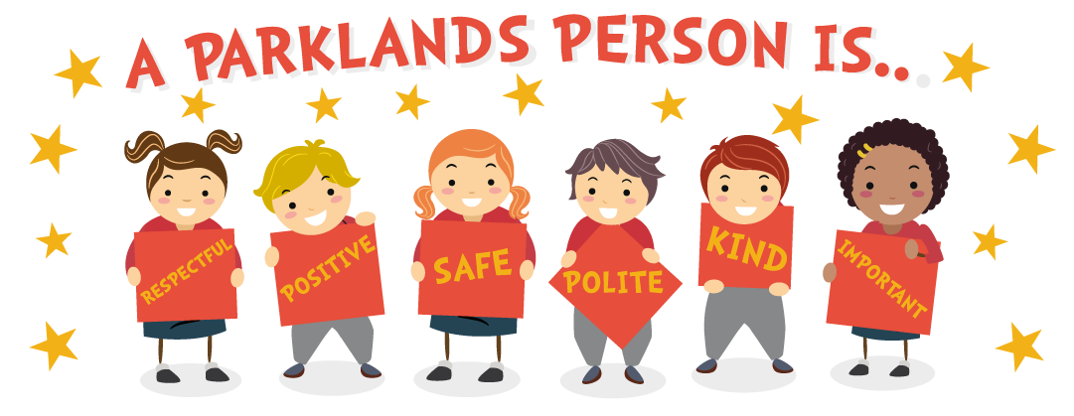

Consultation
The policy was put together by Hayley Hayward and Laura Chivers in consultation with teaching staff, pupils, parents/carers and school governors.

Intent
At Parklands, it is our intent that we make music an enjoyable learning experience. We encourage children to participate in a variety of musical experiences through which we aim to build up the confidence of all children. Our teaching focuses on developing the children’s ability to understand rhythm and follow a beat. Through singing songs, children learn about the structure and organisation of music. We teach them to listen and to appreciate different forms of music. Children develop descriptive language skills in music lessons when learning about how music can represent different feelings, emotions, and narratives. We also teach technical vocabulary such as volume, pitch, beat and rhythm and encourage children to discuss music using these terms. The aim of the progressive Music curriculum is to ensure children gain detailed and connected knowledge and remember what has been learned previously. Teachers plan the curriculum together to ensure full coverage and progression of the Music curriculum is achieved, without causing cognitive overload.

Implementation
Our pupils will learn that music is a universal language that embodies one of the highest forms of creativity. They will be inspired and engaged by music education through the use of our chosen music scheme - Kapow. Kapow fits into the way we plan our curriculum at Parklands – including knowledge retrieval and skills practise. The scheme provides children with opportunities to link their knowledge from previous years. To make Music an enjoyable learning experience we offer lessons including glockenspiels. These will engage and inspire pupils to develop a love of music and develop their talent as musicians, and in turn increase their self-confidence, creativity, and sense of achievement. Teachers ensure that key vocabulary is constantly modelled, explained and encouraged to ensure it is embedded. Our curriculum identifies and sequences the disciplinary knowledge that children need in order to appraise, perform, compose and improvise music. As pupils progress, they should develop a critical engagement with music, allowing them to compose, and to listen and to critique pieces of music.
Wider experiences
We have strong links with our local secondary school who perform live music with a range of instruments. The children also have the opportunity to learn familiar songs and sing along with the performers. Key Strings visit once per year to introduce the children to a range of string instruments which they then play for the children. Children also participate in World Music Day, where they learn about different genres of music and experience live music. Children in KS1 have the opportunity to take part in ‘Singing Club’ where they perform a song at our Summer concert.

Impact
The impact of our Music curriculum is for children to acquire the age-related knowledge and skills in order to appraise, perform, compose and improvise music.
- Children will develop the language in order to be able to appraise music they hear. They will have the opportunity to listen to a wide range of genres of music to broaden their experiences.
- Children will develop skills to allow them to play a range of instruments and sing a variety of songs. Children will develop the confidence to perform to an audience.
- Children will have the technical knowledge to be able to compose their own short pieces of music – including the use of musical notation.
- Children will have the knowledge and confidence to explore different ways of representing music.
Children will remember more of what they have learned and make links between previous learning to make it more meaningful.

Section 2: Procedures and Practice

Roles and Responsibilities
The Music leader is responsible for providing an overview of the subject across the school to inform staff planning and to over advice in which the curriculum can be delivered in an effective and engaging way. They should have an up-to-date knowledge of the subject requirements and ensure that these are met across the school, as well as having an overview of assessment. They are responsible for ensuring that an overview of the subject is available on the school website. The Music leader also has a sound knowledge of the resources which are available within school and ensures that resources are replenished and updated as necessary. The Music leader is responsible for the planning and implementation of any subject specific events which are ran in the school.
Individual teachers are responsible for the day-to-day planning, delivery and assessment of the Music curriculum. The relevant governor is responsible for ensuring there is a good professional dialogue with the subject leader throughout the school year.

Section 3: Aspects
SMCS and British Values
We will ensure that these aspects and values are integrated into and fostered through the children’s education in Music at Parklands.
Spiritual Education
Through a well-balanced curriculum, Music provides a variety of opportunities for children to express themselves through singing and using instruments. They are encouraged to compose sound stories and simple music in response to stimuli including nature, for example the weather. They can speak about how music makes them feel.
Moral education
Through musical activities at Parklands children have opportunities to encounter pieces of music which evoke a range of emotions and raise questions, exploring how music can convey human emotions such as sadness, joy, or anger. They can begin to understand the self-discipline required to perform.
Social education
In Music children can collaborate as groups, supporting each other in forming ideas and working towards a common outcome. They listen to others’ ideas and can cooperate and share expertise. They begin to learn how music impacts on society through public performance and the media.
Cultural Education.
Music provides excellent opportunities for children to experience work and performances by composers and performers people from a variety of cultures. Through listening to the work of musicians and composers they can have a range of viewpoints and influences. The children have opportunities to experience some live performances.
Democracy
All children can take part in musical activities, regardless of ethnicity, gender or ability. They have opportunities to be involved in decision making processes regarding their learning and particularly in group activities.
Individual liberty
Music provides many opportunities for children to make choices and express personal preferences. They can control the direction of their learning in making music and explore sounds and processes of interest to them.
The rule of law
Whilst creativity allows for personal expression, children are taught to use instruments and resources, including ICT, with care to ensure the safety of others. They understand the need for compliance with rules to ensure that they can work together.
Mutual respect and tolerance.
Children are taught to respect each other, and adults, and to base their behaviour on the ‘Parklands Person’ principles. They learn that everyone is different, but everyone is equally important. We help children to develop their awareness of people’s differences and similarities, and to value the rich diversity of people. Musical experiences teach them that there is a wide range of possibilities and there are no right or wrong answers. They learn to evaluate their own and others’ work and respect opinions.

Planning
Music is planned and adapted from the ‘Kapow’ music scheme, this is consistent across EYFS and KS1. Kapow works for Parklands because:
- Knowledge and skills are revisited in every lesson allowing pupils to embed learning.
- Its interactive and fun nature, this ensures it is appealing for all learners.
- For teachers CPD is constantly offered and updated

In Early Years, music is covered within the ‘Expressive Arts and Design’ strand. Our Nursery children are introduced to the songs and rhymes and have the opportunity to explore musical instruments during child led activities. In Reception, children access the full scheme of work in a stand-alone music session.

In Key Stage One a progression document has been developed which outlines the progressive disciplinary knowledge. The plan has been broken down into component parts each of which is a song that the children learn. This develops their disciplinary knowledge and skills. Each half term the musical skills are revisited and built upon to allow for consolidation and progression.

Teaching and Learning

A variety of teaching and learning styles are used within our Music lessons in order to develop children’s knowledge, skills and understanding. Previous knowledge is constantly referred to and built upon so that children can make meaningful links between what they learn. Key vocabulary is modelled, repeated and displayed to ensure children’s understanding and encourage their use of it. Children are encouraged to be the talkers with methods such as talk partners, peer support and self-assessment. Teachers will carefully ensure that children’s musical knowledge is developed and deepened as a part of music lessons without causing cognitive overload using a range of strategies. Children will use technology in lessons where it enhances their learning. They take part in discussions and have the opportunity to perform their work to the rest of the class/year group. The music leaders have developed knowledge organisers which can be used as a tool to aid memory retrieval. Music is displayed on Learning Journeys across EYFS and KS1. A musical vocabulary display is prominent in a central location within our ‘Family Room’.

Music is taught in the EYFS as an integral part of the topic work covered during the year. We relate the musical aspects of the children’s work to the objectives set out in the Expressive Arts and design strand, although music and singing is utilised as a vehicle for development across the whole curriculum and provisions.
As part of a topic-based curriculum children are given the opportunity to take part in activities which allow them to begin to explore the elements of pitch, duration, dynamics, tempo and timbre. They begin to develop skills of control of simple sound makers, copying and creating rhythm, they work on a small and large scale and cooperate with others. Opportunities are provided both indoors and outside. They are introduced to the work of other musicians and begin to develop cultural awareness. The opportunity to perform and celebrate our pupil’s musical talents is shared with parents at topic celebrations, concerts and school talent shows.

Organisation
In the Early Years Foundation stage opportunities for development in music as an element of Expressive Arts and Design are provide both through continuous provision and focused adult led activities which occur daily.
KS1 music is taught through the learning challenge curriculum in response to weekly questions which provide a context for the exploration of musical elements and the opportunities listen to a range of music. The three areas of performing appraising and composing are covered across the year.

Assessment

Teachers make a termly assessment of children’s performance in music. A variety of strategies, including questioning, discussion and observations are used to assess progress. Children who do not meet expectations will be identified on feedback sheets and this will be used to inform assessment data. This is recorded on ‘Insight tracking’ which is our internal record programme. In Early Years teachers assess against the Early Learning Goal under the Expressive Arts and Design area.

In Early Years assessment is by continuous observation, listening and interaction with the child. Pupils learning is recorded and shared using Tapestry (online journal) Throughout the Early Years Foundation stage their progress is tracked against the age-related Development Matters statements. Each child’s experience of the world is different, so the role of the adult is to recognise the need for sensitive intervention to extend their learning appropriately. To encourage self-evaluation and critical appreciation, children are given the opportunity to talk about their work at the end of a session in terms of what they have learnt to do or discovered in the process of making their work.

Monitoring

The planning for Music is reviewed by the curriculum coordinator to ensure coverage and progression. Staff are periodically offered CPD sessions ran by Kapow to ensure that their knowledge is kept up to date. In addition, observations and pupil voice interviews are carried out, which enable the coordinator to propose developments to enhance teaching and learning. Monitoring exercises are carried out termly in accordance with the science action plan. Reports are shared with staff and the responsible governor.

SEND Provision
To make music lessons inclusive, teachers need to anticipate what barriers to taking part and learning activities, lessons or a series of lessons may pose for pupils with particular SEND and/or disabilities. So, in your planning you need to consider ways of minimising or reducing those barriers so that all pupils can fully take part and learn. In some activities, pupils with SEND and/or disabilities will be able to take part in the same way as their peers. In others, some modifications or adjustments will need to be made to include everyone. For some activities, you may need to provide a ‘parallel’ activity for pupils with SEND and/or disabilities, so that they can work towards the same lesson objectives as their peers. There is no specific intervention for Music as Kapow is accessible to all with a range of outcomes and levels of support.

Parent/ Carer Partnership
Parental involvement is encouraged, with attention drawn to activities via newsletters, information on the website and displays in school. Homework may involve research or practising a particular skill. Parents/carers are invited to support their children in school, to contribute any skills and knowledge they may have in an area being taught. Parents/carers are invited to class celebrations of work as a culmination of learning in each learning challenge enquiry and to whole school performances.

Section 4: Conclusion

Monitoring and Review
The governor with responsibility for Music is primarily responsible for monitoring the implementation of this policy. This will be through ongoing discussion with the subject leader and consideration of the evidence gathered in the subject file. The governor will report on this to the curriculum committee. The work of the subject leader is also subject to review by the head teacher as part of our performance management arrangements.

Other Documents and Appendices
The Music policy should be read in conjunction with our policies for curriculum, teaching and learning, assessment, the EYFS policy and the Arts policy

Governor Approval and Review Dates
The policy is to be reviewed annually.

Appendix 1

Reception units of work
Autumn 1  Exploring Sound | Autumn 2  Celebration Music | Spring 1  Music and Movement | Spring 2  Musical Stories | Summer 1  Transport | Summer 2  Big Band

Year One units of work

Year Two units of work

