Art Medium Term Plan
Spring Term Year One
Painting
What are Primary and Secondary colours?
Can you use primary colours to change a colour? |  | How do you show primary and secondary colours on a colour wheel. |  | Can you paint only using warm colours.
 | Can you paint with only cool colours |  | Can you paint in the style of Monet, Paul Klee using warm and cool colours
Substantive Knowledge
- know that primary colours are red, blue, yellow.
- know that secondary colours are green, purple and orange.
- know that mixing colours makes new colours.
- know that colours can be represented on a colour wheel.
- Know that warm colours are red, yellow, orange.
- know that cool colours are blue,green and purple
Disciplinary Knowledge
Art skills |  |  |  | Artist Enquiry
- I can make secondary colours using primary colours.  - I can select and make the correct colour to represent my ideas and planned effect |  |  |  | - View and review different Artist’s work eg Monet and Paul Klee
Resources and websites |  |  |  | Vocabulary:  (including definitions)
Possible activities  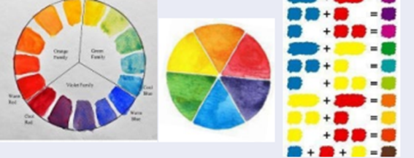 Colour mixing  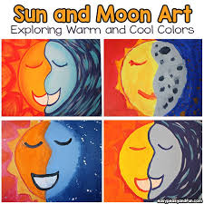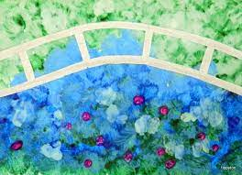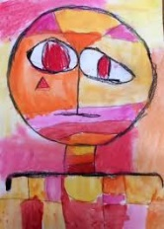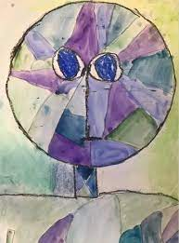  Warm and cool colours  In the style of Monet and Paul klee (warm /cool colours) |  |  |  |  | Primary colours-Are colours which cannot be created by mixing other colours Red. Blue ,and yellow
 |  |  |  |  | Secondary colours -Is a colour made by mixing of two primary colours. Orange, green, purple,
 |  |  |  |  | Warm colours -Red, orange and yellow
 |  |  |  |  | Cool colours Blue, green, violet
EYFS
Colour names
Mixing colours

